Chapter 11, Problem 66.

Obtain the average power absorbed by the 6-kΩ resistor in the op amp circuit in Fig. 11.85.

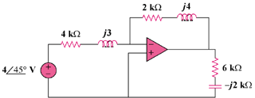

j3 kΩ

j4 kΩ

Figure 11.85
For Prob. 11.66.

